EX NO 16: Annotated Parse Tree Evaluation

Aim:
To construct an annotated parse tree for an arithmetic expression and evaluate its value using the given grammar.
Algorithm:
- Start the program.
- Read the arithmetic expression containing two numbers and the + operator.
- Create parse tree nodes for the numbers using T → num.
- Construct the expression tree using E → E + T and E → T.
- Annotate each node with its evaluated value.
- Display the annotated parse tree.
- Print the final result and stop.

Program:
#include &lt;stdio.h&gt;
#include &lt;stdlib.h&gt;
#include &lt;ctype.h&gt;

typedef struct Node {
char name[10];
int val;
struct Node *left, *right;
} Node;

// Create a new node
Node* createNode(char *name, int val,
Node *left, Node *right) {
Node *n = (Node*)malloc(sizeof(Node));

sprintf(n-&gt;name, &quot;%s&quot;, name);
n-&gt;val = val;
n-&gt;left = left;
n-&gt;right = right;

return n;
}

// Parse T -&gt; num
Node* parseT(char **s) {
int num = 0;

while (isdigit(**s)) {
num = num * 10 + (**s - &#39;0&#39;);
(*s)++;
}

return createNode(&quot;T&quot;, num,
createNode(&quot;num&quot;, num, NULL, NULL),
NULL);
}

// Parse E -&gt; E + T | T
Node* parseE(char **s) {
Node *left = parseT(s);

while (**s == &#39;+&#39;) {
(*s)++;

Node *right = parseT(s);

int result = left-&gt;val + right-&gt;val;

left = createNode(&quot;E&quot;, result,
left, right);
}

return left;
}

// Display annotated parse tree
void display(Node *root, int level) {
if (root == NULL)
return;

for (int i = 0; i &lt; level; i++)
printf(&quot; &quot;);

printf(&quot;%s = %d\n&quot;, root-&gt;name, root-&gt;val);

display(root-&gt;left, level + 1);
display(root-&gt;right, level + 1);
}

int main() {
char expression[100];
char *s;

printf(&quot;Enter arithmetic expression: &quot;);
fgets(expression, sizeof(expression), stdin);

s = expression;

Node *root = parseE(&amp;s);

printf(&quot;\nAnnotated Parse Tree:\n&quot;);
display(root, 0);

printf(&quot;\nFinal Evaluated Value = %d\n&quot;,
root-&gt;val);

return 0;
}

Sample input:
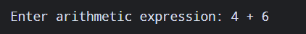
Sample output:
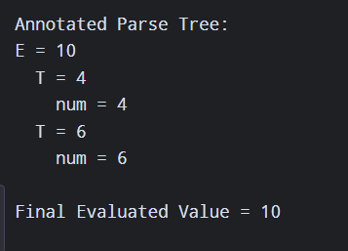

Result:
The annotated parse tree was constructed successfully, and the expression 4 + 6 was evaluated as 10.

